MINISTRY OF EDUCATION AND SCIENCE OF UKRAINE NATIONAL TECHNICAL UNIVERSITY

“KHARKIV POLYTECHNIC INSTITUTE”

DEPARTMENT OF SOFTWARE ENGINEERING AND MANAGEMENT INFORMATION TECHNOLOGIES

### PROGRAMING BASICS

### Laboratory Training 1

# Design of Algorithms

Executed by: SALEM CHAOUFI of group КН-221 iв.e

KHARKIV 2021

REPORT :

## Training Tasks :

### 1 Implementation of a Branching Algorithm

Implement an algorithm for solving quadratic equation. The algorithm should consider all possible data. In particular, the discriminant should be checked, and it should be checked whether the equation is quadratic. If the equation degenerates into a linear one, it is necessary to provide for finding the root of this linear equation, or to establish the presence of infinite count of solutions (absence of solutions). Use the UML Activity diagram for algorithm presentation.

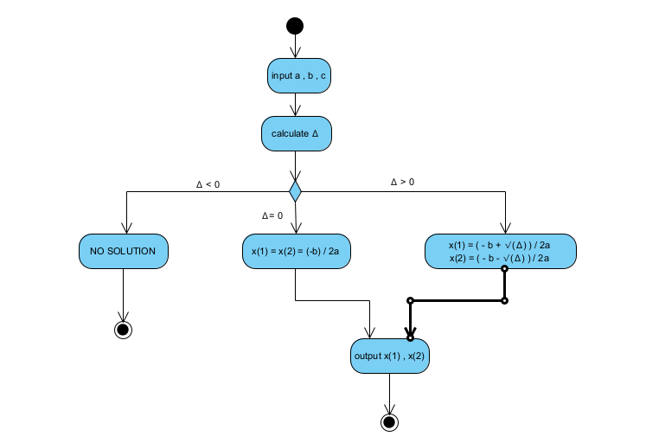

### 2 Implementation of a Looping Algorithm

Implement an algorithm for calculating the following expression:

*y* = 1/(*x* + 2) + 2/(*x* + 4) + ... + (*k* - 1)/(*x* + 2(*k* - 1)) + (*k* + 1)/(*x* + 2(*k* + 1)) + ... + *n*/(*x* + 2*n*)

Use the UML Activity diagram for algorithm presentation. Provide a check of possible errors.

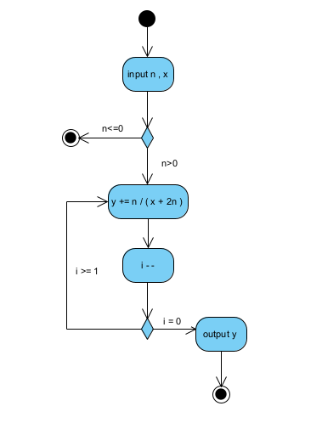

### 3 Individual Assignment

You should develop an algorithm of a program that calculates values of a function in a given range. Your program should read interval boundaries, step of argument increasing, and n value.

Your algorithm should be represented using the UML Activity diagram. It should contain such parts:

* data reading
* main loop, in which you set a new value of an argument and show both this value and calculated value of a function; then need to increase the argument value.

The particular function is given in the individual task according to your own index in the group students list (index of variant).

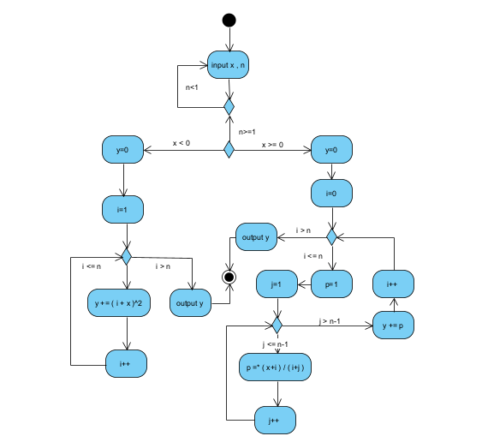

**Conclusion :**

**Because of this part ( algorithm and design ), now I know how to Think cleverly before writing code with the way algorithms work using the UML Activity diagram.**